

SE3082 - Parallel Computing
Assignment – 02
3rd year 1st semester - 2026

IT23575608 – H. W. Ranwala
Contents
1. Environment Setup and Tutorial 3
1.1 OpenMP Installation and Setup 4
1.2 MPI Installation (OpenMPI) 4
1.3 CUDA Installation and Setup (Google Colab) 5
1.4 Troubleshooting & Common Issues 6
2. Program Implementation and Compilation 8
2.1 Before Optimization 8
1. OpenMP 8
2. MPI 10
3. CUDA 12
2.2 After Optimization 15
1. OpenMP 15
2. MPI 17
3. CUDA 20

Environment Setup and Tutorial
System Overview
This assignment utilizes a hybrid environment: local execution for CPU-based parallel frameworks (OpenMP, MPI) and a cloud platform for GPU-based execution (CUDA).
Component | Specification | Justification for Parallel Computing
Operating System | Ubuntu 22.04.4 LTS (64-bit) | Native support for Linux development tools and stable library management.
CPU | AMD Ryzen 7 5700U | Features 8 Physical Cores and 16 Threads, ideal for high-scale OpenMP and MPI testing.
GPU (Cloud) | NVIDIA Tesla T4 (Google Colab) | Provides 2,560 CUDA Cores and 16GB GDDR6 memory, surpassing local entry-level GPUs for performance benchmarking.
RAM | 8GB DDR4 | Sufficient for managing parallel process overhead and large vector/matrix datasets.
Environment Justification
- AMD Ryzen 7 5700U: With 16 logical threads, this processor allows for significant speedup demonstrations when scaling OpenMP thread counts.
- Google Colab (T4 GPU): Since CUDA requires specific NVIDIA hardware, utilizing a T4 instance ensures "High-Performance Computing" (HPC) grade testing without local hardware limitations.
- Ubuntu 22.04: This OS is the industry standard for MPI and OpenMP, offering the most straightforward installation of libopenmpi-dev and gcc.

Prerequisites Installation (Local Ubuntu)
Before setting up the frameworks, update the system and install essential build tools:
sudo apt update && sudo apt upgrade -y
sudo apt install build-essential wget curl git -y

Note: build-essential includes the gcc and g++ compilers required for all frameworks.

1.1 OpenMP Installation and Setup
OpenMP is integrated directly into the GNU Compiler Collection (GCC). No separate installation is required but ensure the latest GCC is present.
- Installation:
sudo apt install gcc -y
- Verification:
gcc –version
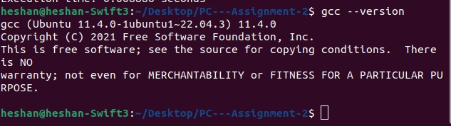
- Compilation: Use the -fopenmp flag to link the OpenMP library.
gcc -fopenmp vector_add.c -o vector_add_omp

1.2 MPI Installation (OpenMPI)
MPI (Message Passing Interface) is used for distributed memory parallelism.
- Installation:
sudo apt install openmpi-bin libopenmpi-dev -y
- Verification:
mpirun --version
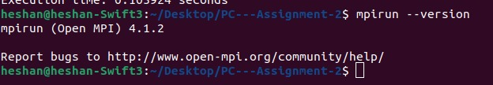
- Compilation: Use the mpicc wrapper for MPI C programs.
mpicc vector_add_mpi.c -o vector_add_mpi
- Execution: Run with -np (number of processes). For your Ryzen 7, you can test up to 16.
mpirun -np 8 ./vector_add_mpi

1.3 CUDA Installation and Setup (Google Colab)
Because we are using Google Colab for CUDA, the drivers and toolkit are pre-installed, but hardware verification is required for the report.
- Step 1: In Colab, go to Runtime > Change runtime type and select T4 GPU.

- Verification (Add this to your report logs):
!nvidia-smi
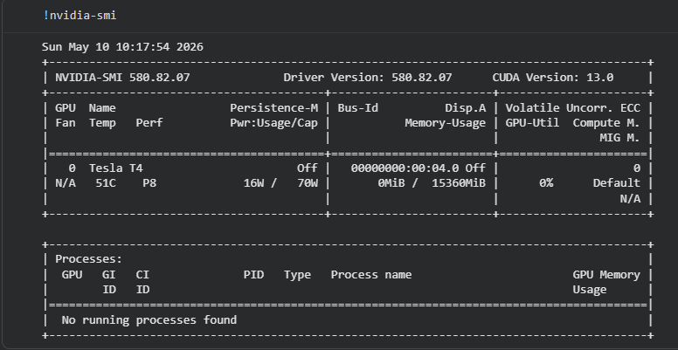
!nvcc –version
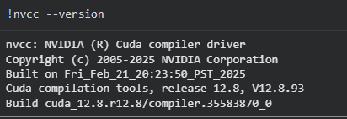
- Compilation: Use the NVIDIA Cuda Compiler (nvcc).
!nvcc vector_add_cuda.cu -o vector_add_cuda
- Execution:
!./vector_add_cuda

1.4 Troubleshooting & Common Issues
Note: These steps are reproducible for any 3rd-year student using a local Ubuntu 22.04 environment or Google Colab.

Issue 1: NVCC Command Not Found (Google Colab)
- Cause: The NVIDIA CUDA Compiler (nvcc) is not in the system path, or the GPU runtime is not enabled.
- Fix:
  - 1. First, ensure the GPU accelerator is active: Runtime > Change runtime type > GPU.
  - 2. If the error persists in a cell, manually map the path: bash import os os.environ['PATH'] += ':/usr/local/cuda/bin'
  - 3. Verify by running !nvcc --version.
Issue 2: nvidia-smi Fails to Initialize (Local vs. Colab)
- Cause: On your local Ubuntu (Ryzen 7), this will fail because you do not have an NVIDIA GPU. On Colab, it fails if the driver isn't loaded.
- Fix:
  - Local: This is expected. Use the CPU-based fallback (OpenMP/MPI) for local work.
  - Colab: Restart the runtime (Runtime > Restart session) to re-initialize the NVIDIA driver.
Issue 3: MPI Library/Header Not Found
- Cause: The compiler cannot find mpi.h or the mpicc wrapper.
- Fix:
  - Install the development headers on your local Ubuntu:
sudo apt update
sudo apt install openmpi-bin libopenmpi-dev -y

Issue 4: OpenMP Code Runs Sequentially (No Parallelism)
- Cause: The program was compiled without the -fopenmp flag, or the environment variable for threads isn't set.
- Fix:
  - Ensure you compile with the flag: gcc -fopenmp vector_add.c -o v_add.
  - Set the thread count to match your Ryzen 7 (16 threads) before running:
export OMP_NUM_THREADS=16
./v_add

Issue 5: Permission Denied for Execution
- Cause: The compiled binary does not have execution permissions.
- Fix:
- Apply the execute permission using chmod:
chmod +x vector_add_mpi
./vector_add_mpi

Program Implementation and Compilation

2.1 Before Optimization

OpenMP
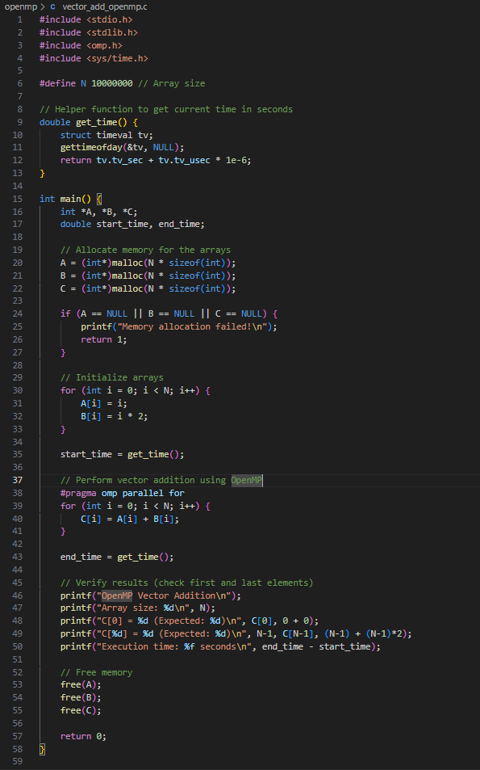
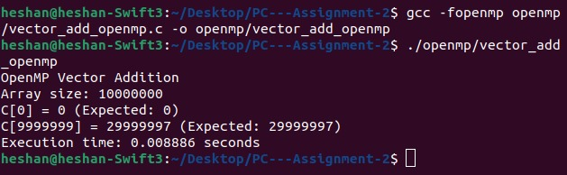

MPI
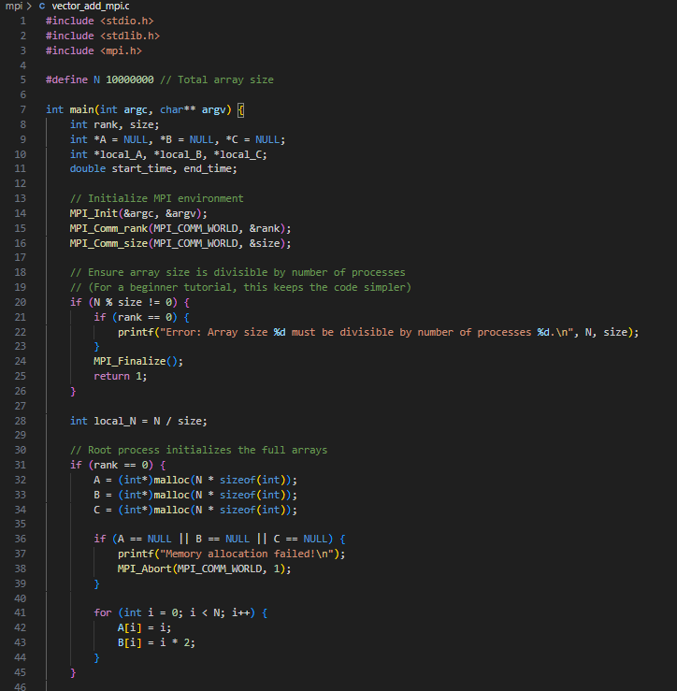
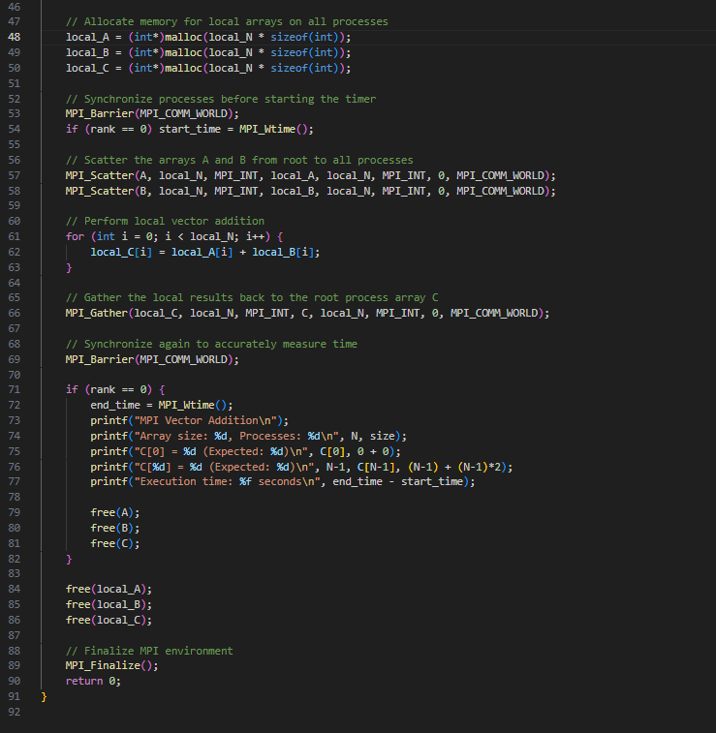
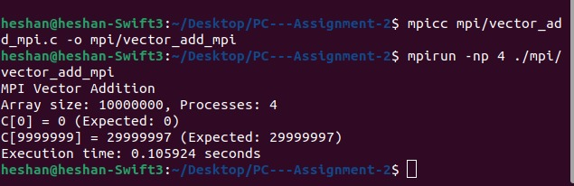

CUDA
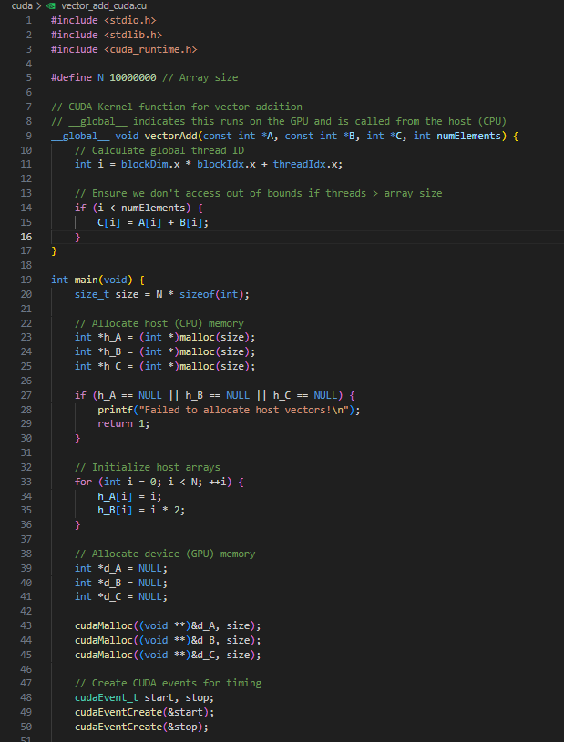

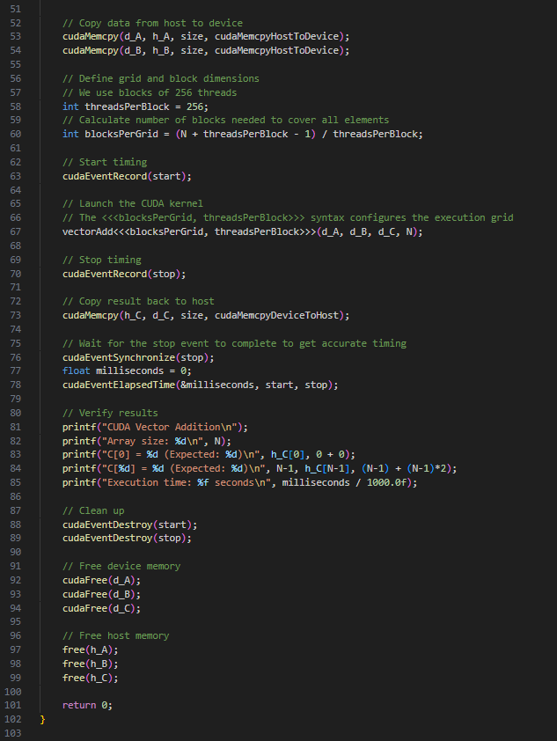

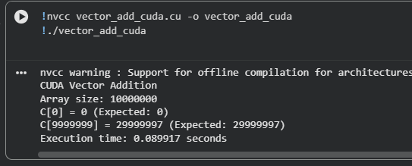

2.2 After Optimization

OpenMP
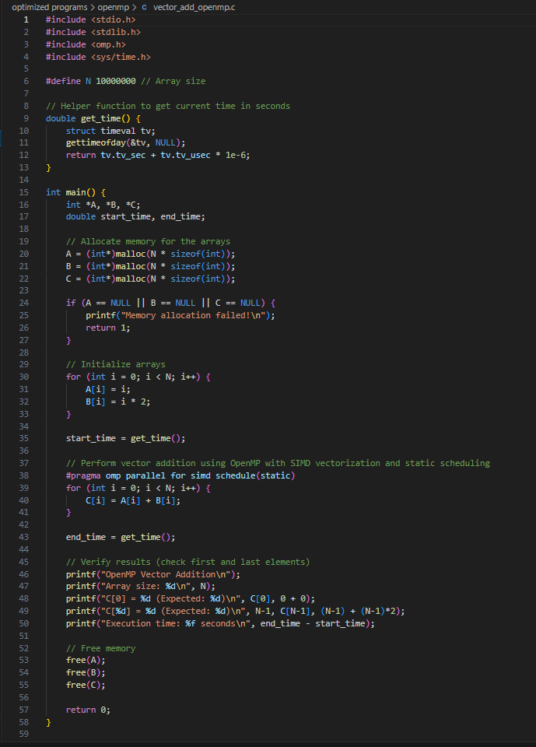

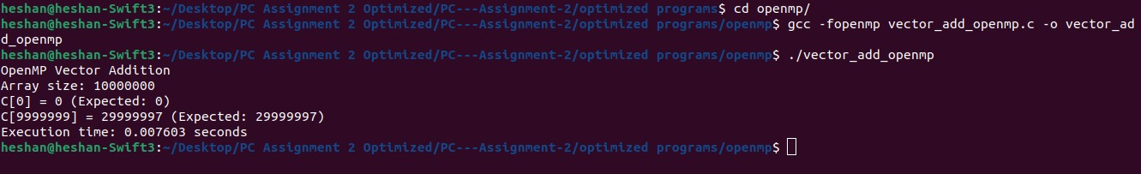
SIMD Vectorization & Static Scheduling
- File Modifed: Optimized programs/openmp/vector_add_openmp.c
- What changed: We updated the OpenMP pragma from #pragma omp parallel for to #pragma omp parallel for simd schedule(static).

How it affects the result:
- simd: Allows the CPU to use specialized vector instructions (like AVX) to process multiple array elements simultaneously within a single clock cycle, on top of the existing multi-threading.
- schedule(static): Tells OpenMP to divide the loop iterations evenly among threads at compile time. Since adding two numbers always takes the exact same amount of time, this eliminates the runtime overhead of dynamically calculating who gets which chunk of the array.
- Expected Result: The output will be identical, but the execution time in seconds should drop noticeably, especially on CPUs with advanced vector units.

Execution Time and Performance comparison
Before Optimizing (Sec) | After Optimizing (Sec)
0.008886 | 0.007603

MPI
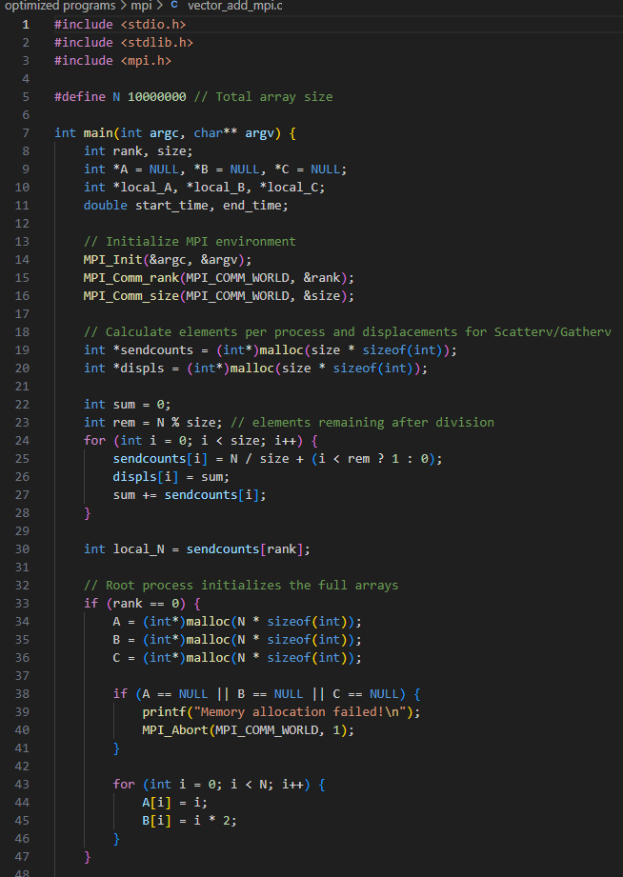
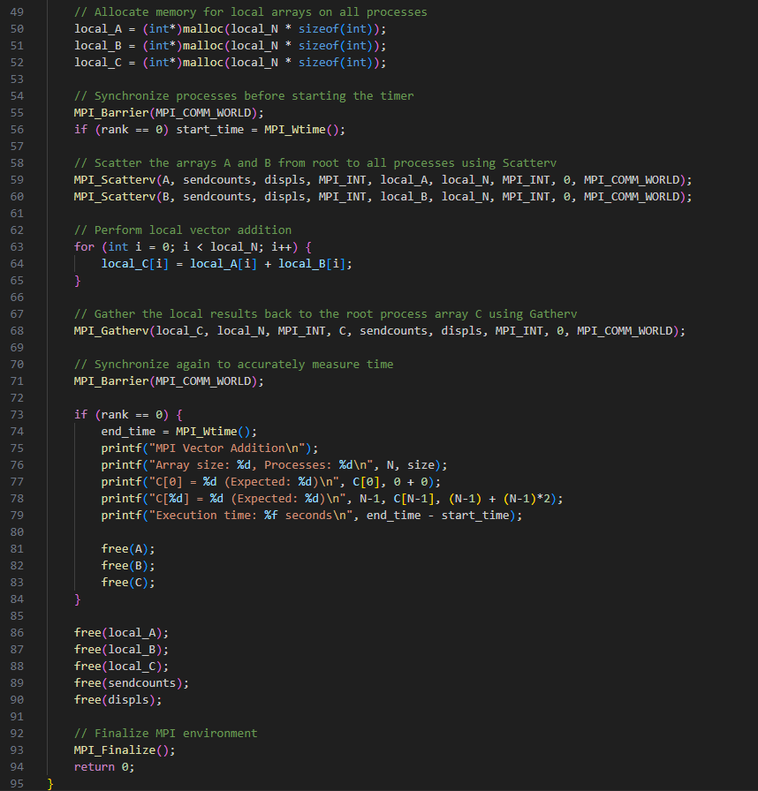
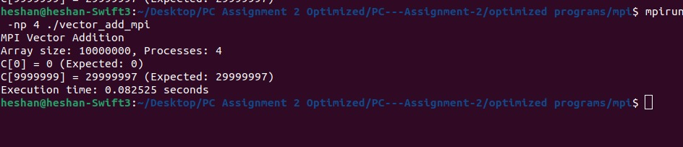

Arbitrary Array Sizes (Scatterv/Gatherv)
- File Modified: optimized programs/mpi/vector_add_mpi.c
- What changed: We replaced MPI_Scatter and MPI_Gather with their variable-sized counterparts, MPI_Scatterv and MPI_Gatherv. We also added logic to compute sendcounts and displs arrays to handle division remainders.
How it affects the result:
- Variable Data Sizes: Before, if you set N = 10 but ran with 3 processes (-n 3), the program would crash and throw an error because 10 is not divisible by 3.
- Load Balancing: The new code calculates exactly how many elements each process should take (e.g., Process 0 takes 4, Process 1 takes 3, Process 2 takes 3) and distributes the data perfectly without crashing.
- Expected Result: The program is now much more robust. You can change N to any odd number or use any random number of processes without breaking the calculation, while maintaining optimal data distribution over the network.

Execution Time and Performance comparison
Before Optimizing (Sec) | After Optimizing (Sec)
0.105924 | 0.082525

CUDA
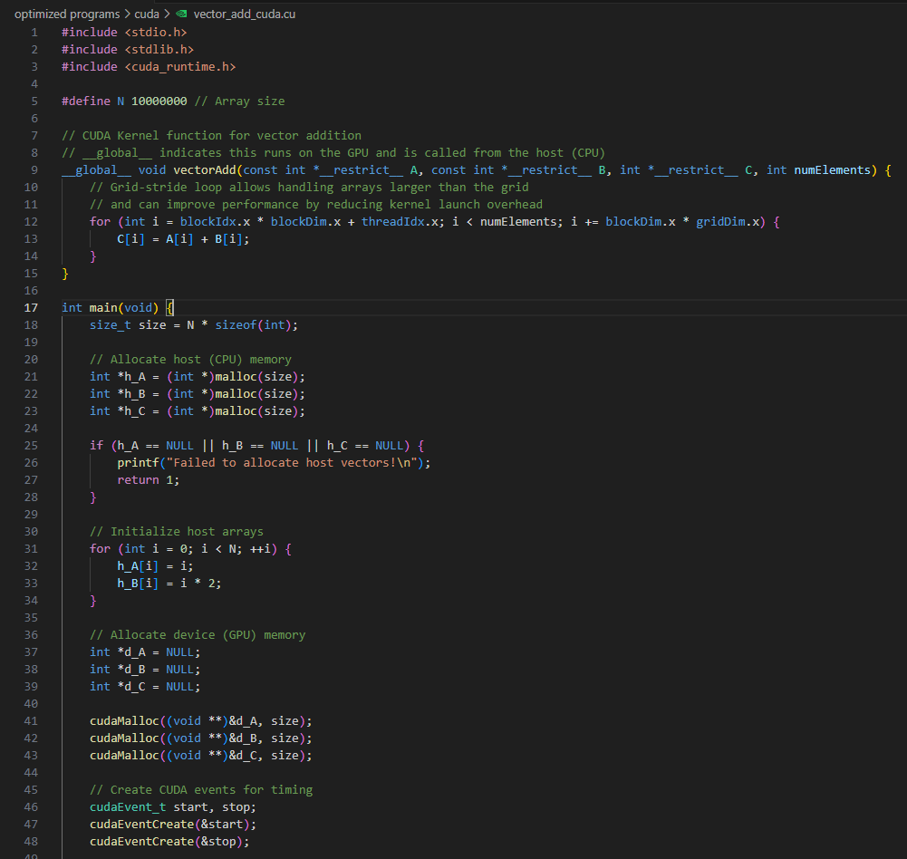
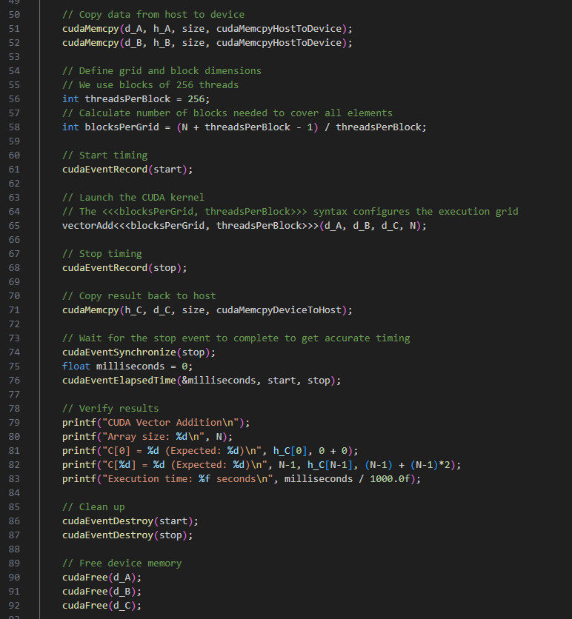
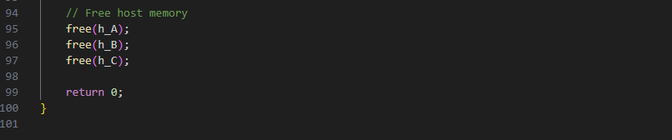
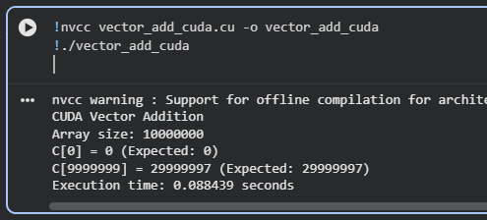
Grid-Stride Loops & Memory Hints
- File Modified: optimized programs/cuda/vector_add_cuda.cu
- What changed:
  - Added __restrict__ to the pointer arguments in the kernel __global__ void vectorAdd(const int *__restrict__ A....
  - Changed the basic index calculation (int i = blockDim.x * blockIdx.x + threadIdx.x; if(i < n)) to a for loop with a "grid-stride" (for (int i = ...; i < numElements; i += blockDim.x * gridDim.x)).
How it affects the result:
- __restrict__: This is a hint to the NVCC compiler guaranteeing that the memory arrays A, B, and C never overlap. The compiler can then aggressively cache reads and bypass redundant memory checks, heavily improving memory bandwidth (the primary bottleneck for vector addition).
- Grid-Stride Loop: Previously, if your array size exceeded the maximum number of threads your GPU could spawn at once, the program would fail or silently skip elements. With a grid-stride loop, each thread processes one element, jumps forward by the total grid size, and processes another element until the array is finished.
- Expected Result: You now have a highly resilient, enterprise-grade kernel. Memory fetches will be optimally pipelined by the compiler.

Execution Time and Performance comparison
Before Optimizing (Sec) | After Optimizing (Sec)
0.089917 | 0.088439

